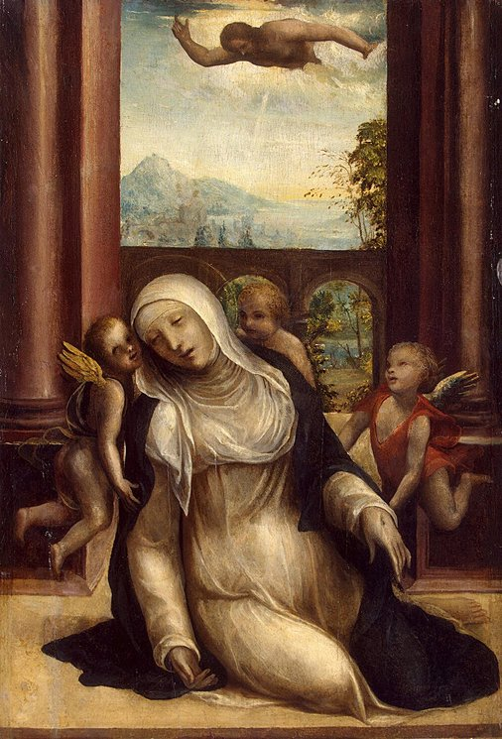
Born: 25 March 1347
Returned to God: 29 April 1380
From her earliest childhood Catherine began to see visions and to practise extreme austerities. At the age of seven she consecrated her virginity to Christ; in her sixteenth year she took the habit of the Dominican Tertiaries, and renewed the life of the anchorites of the desert in a little room in her father's house. After three years of celestial visitations and familiar conversation with Christ, she underwent the mystical experience known as the "spiritual espousals", probably during the carnival of 1366. She now rejoined her family, began to tend the sick, especially those afflicted with the most repulsive diseases, to serve the poor, and to labour for the conversion of sinners. Though always suffering terrible physical pain, living for long intervals on practically no food save the Blessed Sacrament, she was ever radiantly happy and full of practical wisdom no less than the highest spiritual insight. All her contemporaries bear witness to her extraordinary personal charm, which prevailed over the continual persecution to which she was subjected even by the friars of her own order and by her sisters in religion. [Source: New Advent; picture Wikipedia]
Receiving the Stigmata
While at Pisa, on the fourth Sunday of Lent, 1375, she received the Stigmata, although, at her special prayer, the marks did not appear outwardly in her body while she lived.
During the Great Schism (Avignon & Clement VII/Rome & Pope Urban VI), where Pope Urban VI showed himself whimsical, haughty, suspicious, and sometimes choleric in his relations with the cardinals who had elected him he became too obvious roughness and blameable in extravagances which seemed to show that his unexpected election had altered his character. St. Catherine of Siena, now in Rome, with supernatural courage, did not hesitate to make to the Pope some very well-founded remarks in this respect, nor did she hesitate when there was question of blaming the cardinals in their revolt against the pope whom they had previously elected.
In the Eternal City she spent what remained of her life, working strenuously for the reformation of the Church, serving the destitute and afflicted, and dispatching eloquent letters in behalf of Urban to high and low in all directions. Her strength was rapidly being consumed; she besought her Divine Bridegroom to let her bear the punishment for all the sins of the world, and to receive the sacrifice of her body for the unity and renovation of the Church; at last it seemed to her that the Bark of Peter was laid upon her shoulders, and that it was crushing her to death with its weight. After a prolonged and mysterious agony of three months, endured by her with supreme exultation and delight, from Sexagesima Sunday until the Sunday before the Ascension, she died.
Her writings consist of:
- the "Dialogue", or "Treatise on Divine Providence" (excerpts from this is our reading);
- a collection of nearly four hundred letters; and
- a series of "Prayers".
The "Dialogue" especially, which treats of the whole spiritual life of man in the form of a series of colloquies between the Eternal Father and the human soul (represented by Catherine herself), is the mystical counterpart in prose of Dante's "Divina Commedia". The key-note to Catherine's teaching is that man, whether in the cloister or in the world, must ever abide in the cell of self-knowledge, which is the stable in which the traveller through time to eternity must be born again. [Source: mostly New Advent]
Reflection Questions
Biblical Reflection Question:
Paul tells us, “Now I rejoice in my sufferings for your sake, and in my flesh I complete what is lacking in Christ's afflictions for the sake of his body, that is, the church.” Colossians 1:24.
St. Catherine relates God’s word on the matter, “…inasmuch as they [souls] have infinite desire, that is, are joined to Me by an affection of love, and therefore grieve when they offend Me, or see Me offended, their every pain, whether spiritual or corporeal, from wherever it may come, receives infinite merit, and satisfies for a guilt which deserved an infinite penalty….” [lines 37-40]. (See also lines 87-90)
How does the idea of forgiveness, based on your level of grief at the hideousness at your sins and their offensiveness to God (thus your love for God), and your willingness to suffer, either spiritually or corporeally, for them affect or change your thinking on prayer? Are you willing to ask God, in prayer, to suffer for your sins? If not, why not? How about telling God that you are willing to suffer for the sins of others? Is this not what Christ did for us? What do our answers tell us about where we are on our spiritual journey and how much we need Christ in our lives?
Catechism Reflection Question:
Christ speaks to St. Catherine on lines 68-69 teaching her, “No virtue, my daughter, can have life in itself except through charity, and humility, which is the foster-mother and nurse of charity.” St. John Damascene is quoted asking in CCC 2559 if, “…when we pray, do we speak from the height of pride and will or “out of the depths” of a humble and contrite heart”? , noting that humility is the foundation of prayer.
So if humility is both the “foundation of prayer” and “foster-mother and nurse of charity”, is it reasonable that only through obedient, regular, and humble prayer that we can find and build a relationship with God, Who is Charity itself? And thus grow in charity? What other way do you see to grow in Charity? Does it start with loving God or in our own desire to love one another? Does anything need to change in your prayer life?
Spiritual Reflection Question:
Lines 140-141 tell us, “It is, therefore, indeed the truth that every sin done against Me, is done through the medium of the neighbor." While on lines 164-166 God says, “And it cannot be otherwise, because love of Me and of her neighbor are one and the same thing, and, so far as the soul loves Me, she loves her neighbor, because love towards him issues from Me.”
Do you see sins against your neighbors, especially your enemies, as sins against God? If not, why not? CCC 1022 quotes, in part St. John of the Cross, “At the evening of life, we shall be judged on our love.” If you came to accept the truth that your eternal soul’s judgement (divine retribution) hinges upon your cooperation in following Christ’s example and not offending God, not for the sake of the fallible person, but because of the righteousness in Loving the infallible Triune God, would your thinking change? What changes will you make?

