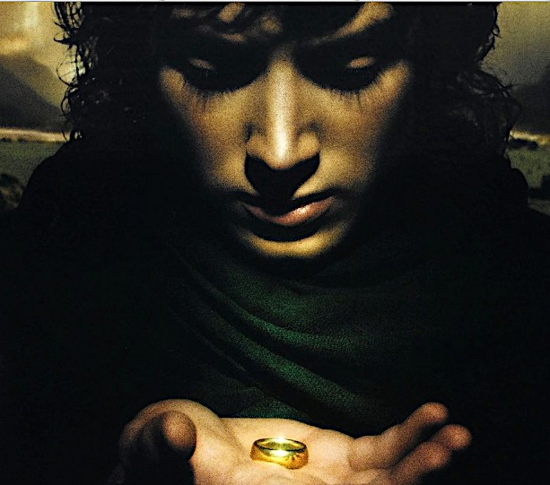
The Catholic Heart of The Lord of The Rings
Quotes and Bibliography

“I wrote The Lord of the Rings because I wished ‘to try my hand at a really long story that would hold the attention of readers, amuse them, delight them, and at times maybe excite them or deeply move them.” Tolkien

“The heart of Christianity is a myth which is also a fact.” C.S. Lewis

“… we make things by the law in which we were made. We create because we are created. Creativity, imagination, is God’s imageness in us. We tell stories because God is a storyteller. In fact he is THE storyteller. We tell our stories with words. He tells his-story with history. The facts of history are his words and his providence is his storyline.”

“Myth and fairy-story must, as all art, reflect and contain in solution elements of moral and religious truth (or error), but not explicit, not in the known form of the primary ‘real’ world.” Tolkien, Letter 131

“The Lord of the Rings is of course a fundamentally religious and Catholic work; unconsciously so at first, but consciously in the revision. That is why I have not put in, or have cut out, practically all references to anything like ‘religion’, to cults or practices, in the imaginary world. For the religious element is absorbed into the story and the symbolism” Tolkien, Letter 142.

“I dislike Allegory – the conscious and intentional allegory – yet any attempt to explain the purport of myth or fairytale must use allegorical language. And, of course, the more ‘life’ a story has the more readily will it be susceptible of allegorical interpretations.”
“Many confuse ‘applicability’ with ‘allegory’, but the one resides in the freedom of the reader and the other in the proposed domination of the author.” Forward to LOTR, xxiv

“Strictly speaking, the whole of history is nothing but the story of God’s activity.” Jean Pierre de Caussade

“In the LOTR the conflict is not basically about ‘freedom,’ though that is naturally involved. It is about God, and His sole right to divine honor… Sauron desired to be a God-King… If he had been victorious he would have demanded divine honor from all rational creatures and absolute temporal power over the whole world.” Tolkien, Letters

“Tolkien designed the story so that the attentive reader would discern the workings of an active transcendent agency…. The human growth and development that form such a gripping part of the plot would not be possible without the unseen but often obliquely identified intrusion of “the Secret Fire” of which Gandalf was a servant. Fleming Rutledge, The Battle for Middle Earth, 8

“One Ring to rule them all, One Ring to find them, One Ring to bring them all and in the darkness bind them; in the Land of Mordor where the Shadows lie.”

“Our duty as Christians lies in this, in making ventures for eternal life without the absolute certainty of success… in “the high adventure of Christian discipleship … which requires sacrifice and self denial.” Bl. John Henry Newman, Parochial and Plain Sermons

“Bilbo used often to say there was only one Road; that it was like a great river: it's springs were at every doorstep and every path was it's tributary. It's a dangerous business, Frodo, going out your door. You step onto the road, and if you don't keep your feet, there's no knowing where you might be swept off to.” LOTR 73
“God has created me to do Him some definite service. He has committed some work to me which He has not committed to another. I have my mission. I may never know it in this life, but I shall be told it in the next. I am a link in a chain, a bond of connection between persons.” Bl. John Henry Newman

“Tolkien consistently moves the reader into the realm of discernment and vocation within the language of “calling” and chance that is not really chance but ordination. Each person has a unique mission in life that only he can do, but he must be open and responsive to divine grace.” Craig Bernthal, Tolkien’s Sacramental Vision, 160-61

“The Ring is destroyed on the same date on which God became man and on which God died for our sins [March 25]. These two events constitute humanity’s redemption from Original Sin. Now we have our connection to the One Ring – it represents sin in general and Original sin in particular” Joseph Pearce, Catholic Courses

“‘Present your bodies as a living sacrifice’, writes St. Paul. “How marvelous is the priesthood of the Christian, for he is both the victim that is offered on his own behalf, and the priest who makes the offering! … Truly it is an amazing sacrifice in which the body is offered without being slain and blood is offered without being shed.” OOR Tuesday, 4th Week of Easter

“I was particularly interested in your remarks about Galadriel… I think it is true that I owe much of this character to Christian and Catholic teaching and imagination about Mary…” Tolkien Letters, 407

“ And yet this waybread [Lembas] of the Elves had a potency that increased as travelers relied on it alone and did not mingle it with other foods. It fed the will, and it gave strength to endure, and to master sinew and limb beyond the measure of mortal kind” (LOTR, 936).

“ At this point, the salvation of the world and Frodo’s own salvation is achieved by his previous pity and forgiveness of injury. At any point any prudent person would have told Frodo that Gollum would certainly betray him and could rob him in the end. To ‘pity’ him, to forbear to kill him, was a piece of folly… He did rob him and injure him in the end – but by a “grace”, that last betrayal was at a precise juncture when the final evil deed was the most beneficial thing anyone could have done for Frodo! By a situation created by his “forgiveness’, he was saved himself and relieved of his burden.” Letters, 234

“True art has a close affinity with the world of faith, so that even in situations where culture and the Church are far apart, art remains a kind of bridge to religious experience… Art by its nature is a kind of appeal to the mystery. Even when they explore the darkest depths of the soul or the most unsettling aspects of evil, artists give voice to the universal desire for redemption.” Pope St. John Paul II; Letter to Artists

Bibliography for The Catholic Heart of The Lord of the Rings
Craig Bernthal, Tolkien’s Sacramental Vision: Discerning the Holy in The Lord of the Rings
Bradley Birzer, J.R.R. Tolkien’s Sanctifying Myth: Understanding Middle Earth
Stratford Caldecott, The Power of the Ring: The Spiritual Vision Behind The Lord of the Rings
Humphrey Carpenter, The Letters of JRR Tolkien
Peter Kreeft: The Philosophy of Tolkien: The Worldview Behind The Lord of the Rings
Joseph Pearce, Tolkien Man and Myth: A Literary Life
Catholic Courses: The Hidden Meaning of The Lord of the Rings featuring Joseph Pearce
Richard Purtill, J.R.R. Tolkien: Myth, Morality & Religion
Fleming Rutledge, The Battle for Middle Earth: Tolkien’s Divine Design in The Lord of the Rings
Tom Shippey, J.R.R. Tolkien: Author of the Century
Ralph C. Wood, The Gospel According to Tolkien: Visions of the Kingdom in Middle Earth

Youtube presentation by Prof. Joseph Pearce: Unlocking the Catholicism in The Lord of the Rings: https://www.youtube.com/watch?v=n27mXqW89oo

