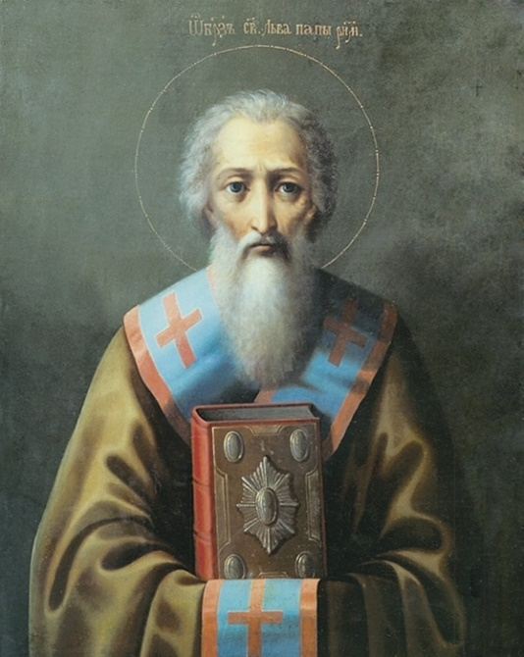
Pope Saint Leo the First, or St. Leo the Great: Doctor and Father of the Church. Memorial on 10 November. Death Nov 10th, 461 AD.
Reference: With apparent strong conviction of the importance of the Bishop of Rome in the Church, and of the Church as the ongoing sign of Christ’s presence in the world, Leo the Great displayed endless dedication as pope. Elected in 440, he worked tirelessly as “Peter’s successor,” guiding his fellow bishops as “equals in the episcopacy and infirmities.”
Leo is known as one of the best administrative popes of the ancient Church. His work branched into four main areas, indicative of his notion of the pope’s total responsibility for the flock of Christ. He worked at length to control the heresies of Pelagianism—overemphasizing human freedom—Manichaeism—seeing everything material as evil—and others, placing demands on their followers so as to secure true Christian beliefs.
A second major area of his concern was doctrinal controversy in the Church in the East, to which he responded with a classic letter setting down the Church’s teaching on the two natures of Christ. With strong faith, he also led the defense of Rome against barbarian attack, taking the role of peacemaker.
In these three areas, Leo’s work has been highly regarded. His growth to sainthood has its basis in the spiritual depth with which he approached the pastoral care of his people, which was the fourth focus of his work. He is known for his spiritually profound sermons. An instrument of the call to holiness, well-versed in Scripture and ecclesiastical awareness, Leo had the ability to reach the everyday needs and interests of his people. One of his sermons is used in the Office of Readings on Christmas.
It is said of Leo that his true significance rests in his doctrinal insistence on the mysteries of Christ and the Church and in the supernatural charisms of the spiritual life given to humanity in Christ and in his Body, the Church. Thus Leo held firmly that everything he did and said as pope for the administration of the Church represented Christ, the head of the Mystical Body, and Saint Peter, in whose place Leo acted.

A Short 3 min YouTube Video: St. Leo the Great (pro tip- skip the ads).

Reflection Questions
Biblical Reflection: Tobit 12:8 Scripture]—Section IV of Sermon 12, St. Leo tells us of our great Christian duties during times of penance, such as during Advent when this sermon was offered, Prayer, Fasting and Alsmgiving. On lines 100-101 St. Leo makes the bold statement that “by alms we redeem our sins”, but it is not as simple as it might appear. The CCC 1434 repeats these duties and points us to Tobit 12:8, when the Archangel Raphael speaks these words, “Prayer is good with fasting and alms more than to lay up treasures of gold: For alms delivereth from death, and the same is that which purgeth away sins, and maketh to find mercy and life everlasting. But they that commit sin and iniquity, are enemies to their own soul.” As St. Leo continues on lines 102-103, these acts of interior penance must be done with the right intention. Love of God and neighbor. When you assess your Prayer, Fasting and Almsgiving, especially your almsgiving, where is your heart? Is there some amendment to your thinking and within your heart that needs to occur?
Catechetical Reflection: Prayer is one of the great duties and privileges we have to commune with God. But how to pray? The CCC gives us some excellent tips. CCC 2664 tells us that we must pray “in the name of Jesus such that the Spirit may teach us to pray to the Father. CCC 2665 instructs us to let the Word (Scripture) instruct our prayer to move our hearts to invokes the numerous Names of God (e.g Savior, Lamb of God, Beloved son, etc.) noting that ins CCC 2666 by invoking the name of Jesus, we invoke “YWWH Saves” as fully God and fully Man, and the whole economy of creation and salvation. This leads us to the highly recommended and ancient prayer from Siani, Syria and Mt. Athos, “Lord Jesus Christ, have mercy on us sinners.” Can you find time for this humble prayer in your day? Do you count yourself among the sinners? Why or why not? What would you need to change to make this prayer part of your day?
Spiritual Reflection: Fasting seems to be a shield against Satan the lies fomented by heresy. St. Leo encourages the faithful to fast on Wednesdays, Fridays and also on Saturdays that we, ”keep vigil in the presence of the most blessed Apostle Peter” (line 246) so that the church and our souls “may be free from all error” (line 249). How do you view fasting? Is it a duty? A drudgery, possibly? Or could you re-imagine it as St Leo offers it- as shield, a spiritual instrument that reveals truth, uncovers the deceptions of Satan, frees you to, “extinguish the lusts of the flesh” (line 100) and “remain innocent” (Line 106)? It’s is notable that St. Leo even says that your intentions of “forgiveness of sins is most efficaciously prayed for with almsgiving and fasting… ” (lines 148-149). Have you struggled with forgiveness? Have you thought of adding fasting and almsgiving to really help move forgiveness forward in your life?

