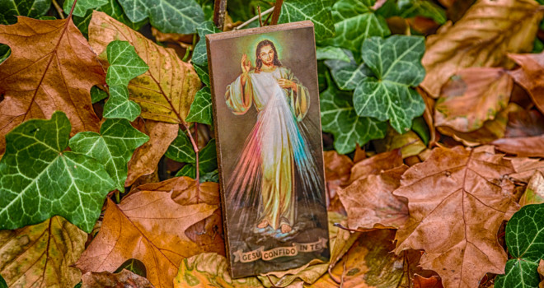
Litany of Trust

From the belief that I have to earn Your love
Deliver me, Jesus.
From the fear that I am unlovable
Deliver me, Jesus.
From the false security that I have what it takes
Deliver me, Jesus.
From the fear that trusting You will leave me more destitute
Deliver me, Jesus.
From all suspicion of Your words and promises
Deliver me, Jesus.
From the rebellion against childlike dependency on You
Deliver me, Jesus.
From refusals and reluctances in accepting Your will
Deliver me, Jesus.
From anxiety about the future
Deliver me, Jesus.
From resentment or excessive preoccupation with the past
Deliver me, Jesus.
From restless self-seeking in the present moment
Deliver me, Jesus.
From disbelief in Your love and presence
Deliver me, Jesus.
From the fear of being asked to give more than I have
Deliver me, Jesus.
From the belief that my life has no meaning or worth
Deliver me, Jesus.
From the fear of what love demands
Deliver me, Jesus.
From discouragement
Deliver me, Jesus.
That You are continually holding me sustaining me, loving me
Jesus, I trust in you.
That Your love goes deeper than my sins and failings, and transforms me
Jesus, I trust in you.
That not knowing what tomorrow brings is an invitation to lean on You
Jesus, I trust in you.
That you are with me in my suffering
Jesus, I trust in you.
That my suffering, united to Your own, will bear fruit in this life and the next
Jesus, I trust in you.
That You will not leave me orphan, that You are present in Your Church
Jesus, I trust in you.
That Your plan is better than anything else
Jesus, I trust in you.
That You always hear me and in Your goodness always respond to me
Jesus, I trust in you.
That You give me the grace to accept
forgiveness and to forgive others
Jesus, I trust in you.
That You give me all the strength I need for what is asked
Jesus, I trust in you.
That my life is a gift
Jesus, I trust in you.
That You will teach me to trust You
Jesus, I trust in you.
That You are my Lord and my God
Jesus, I trust in you.
That I am Your beloved one
Jesus, I trust in you.
Amen.

*This beautiful prayer was written by Sr. Faustina Maria Pia, Sister of Life and originally published on the Sisters of Life website. Visit them at:www.sistersoflife.org

