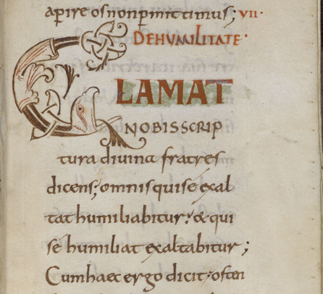
Father of the Church: St. Benedict of Nursia, the Father of Western Monasticism (ca. 480 – ca. Mar 21, 547) Feast Day July 11th (formerly Mar 21). It was moved so an octave celebration could be had. March 21 always fell during Lent and an octave celebration would be prohibited. The Saint was born at Nursia, a small town near Spoleto in central Italy. He is known to be the twin brother to St. Scholastica. Their mother died at their birth. His parents were wealthy landowners (but not part of the aristocracy).
St. Benedict was sent to Rome to study around 500a.d. but decided to drop out after he was distressed by the immorality of the Roman culture and the lackadaisical attitude of his fellow students. He then headed south to the mountains. There he met a monk named Romanus who showed him a cave where he could live as a hermit in the area called Subiaco, which had a spectacular view of the mountain gorge. Romanus, sensing the specialness and holiness of St. Benedict, brought food to St. Benedict every day by lowering it in a basket from the edge of the cliff. A bell at the end of the rope would indicate to St. Benedict that his meal had arrived. He lived like this for about three years.
From the Beginning of Chapter 7, Humility. Image from the RULE, codex written in the late 10th or Early 11th Centuries (British Library), Note after the semi colon “omnis quise exaltat humiliatiur: & quise humiliate exaltabitur…”, see lines 2-3 of the reading (quoting Luke 14:11; 18:14)
St. Benedict’s reputation for sanctity spread throughout the region and men who wanted to pursue the religious life flocked to him. He organized them into twelve communities of ten monks each and an abbot. He stayed there for about twenty-five years, as roman nobles would send their sons to St. Benedict to be educated.
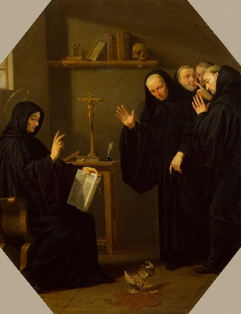
During these twenty-five years that he stayed in Subiaco, he met resistance regarding the strict regime he required of the communities. The success of his communities brought about envy and jealously, at least with one priest named Florentius. Florentius was known to spread lies about St. Benedict, though no one believed him. He tried to keep men from joining St. Benedict, but men kept coming. It was said that Florentius even tried to poison a loaf of bread and deliver it to St. Benedict, begging him to accept it as a token of remorse. By the grace of God, St. Benedict realized the bread was poisoned. He was said to have given it to a raven, commanding the raven to take the bread to a place where no one would find it. In a final effort to ruin St. Benedict’s reputation, Florentius hired prostitutes in vain, hoping it would seduce the monks.
Realizing that Florentius would never stop his attacks on the community, St. Benedict moved his monks to Monte Cassino. It was at Mount Cassino where he wrote the final version of his Rule (of life) (known as the Rule of St. Benedict). Drawing ideas from monastic writers such as Saints Basil, John Cassian, Augustine, the Desert Fathers, Pachomius in Egypt and the Regula Magistri (“Rule of the Master”), he developed his Rule to assist the monks to grow in holiness and to live in community. The Rule of Benedict he wrote for his monks was in part a reaction against the extremes practiced by some monks, particular those who lived in the deserts of the East. Left to their own devices, these monks, almost all of whom lived as hermits, would literally torture their bodies by depriving themselves of sleep, food and water. St. Benedict’s response was to develop a method that was practical, made no irrational demands of the body and could be flexible without compromising its spiritual principles. Source: https://www.stmarymagdalen.org/Catholicism/Saints/StBenedict.htm
“Scene from the Life of St. Benedict. The Poisoned Cup of Wine” Philippe de Champaigne
About the Text: “In the seventh chapter of St. Benedict of Nursia’s holy Rule, the Father of Monks elucidates the steps of humility. Humility is a recurring theme of the saint’s Rule. It is the basis on which monks are distinguished from one another (2,21), rather than on the basis of favoritism or noble birth. It is why, for momentous decisions to be made in the monastery, the younger brothers are to have a say (3,3), since “the Lord often reveals what is better to the younger.” Indeed, the brothers are to all “express their opinions with all humility, and not presume to defend their own views obstinately.” Humility is among the tools for good works the saint discusses in the fourth chapter (4,42-42): “If you notice something good in yourself, give credit to God, not to yourself, but be certain that the evil you commit is always your own and yours to acknowledge.” Humility is the foundation of, and is expressed in, the obedience to the authority of those God has placed over us, as St. Benedict notes in chapter 5. And it is the backbone of the restraint of speech that our Father in God calls his brothers to in chapter 6.
This humility, the saint says, is the ladder to which we ascend into heaven, but only by first descending. The sides of this ladder are our body and our soul, which are joined together by the twelve rungs St. Benedict will enumerate in chapter 7. In other words, humility is not merely an attitude of mind, a feeling of one’s soul, a disposition of one’s heart, it is, indeed, also what one does with one’s body, as evidenced in the rules concerning food and drink in chapters 39-41, as well as the specific manner in which an erring brother is received back into the community (chapter 29). Humility, indeed, is precisely why prayers are to be short and brief (chapter 20).” Source: https://benedictseraphim.wordpress.com/2005/02/10/st-benedict-of-nursia-and-the-twelve-steps-of-humility/
Primer Questions
Biblical Reflection: Of all the works of the Doctors and Fathers of the Church, this is one of the most rich in Scripture quotations - 43 in just 8 pages. Only Steps 8 and 11 do not contain the Word as an anchor for Saint Benedicts ladder to heaven. Do you think that lack of this center piece erodes in anyway the veracity or Sacred calling to follow these Steps? Why or why not? Over half of the Scriptural Citations (24) are taken from Psalms. Does this provide insight into why the Psalter was and is prayed in the Prayer of the Church (Liturgy of the Hours)? Does this move you in any way towards the Word and especially the Psalms?
Catechetical Reflection: The CCC defines Humility as “the virtue by which a Christian acknowledges that God is the author of all good. Humility avoids inordinate ambition or pride, and provides the foundation for turning to God in prayer (CCC 2559). Voluntary humility can be described as “poverty of spirit”(CCC 2546)”. Does the CCC fully capture the twelve steps of humility laid out by St. Benedict? If not, why do you think that is? If so, which steps are mapped the twelve rungs (steps) of the ladder and the sides of the angelic Jacob’s ladder (body and soul) leading us to Heaven?
Spiritual Reflection: Like many other Doctors and Fathers of the Church, St. Benedict reminds us that Humility leads us to Love God – by way of Scripture (1 John 4:18-19) – “Fear is not in charity: but perfect charity casteth out fear, because fear hath sin. And he that feareth is not perfected in charity. Let us therefore love God: because God first hath loved us.” [Douay Rheims Challoner Bible]. Do you work on loving God without humility? Or do you try to be humble and congratulate yourself, or seek the notice of others? Saint Benedict teaches that we first must be humble to allow space in our hearts to Love God. Then we will not be fearful, rather filled with the Holy Spirit’s gift Fear of the Lord (awe in his Greatness and kindness and our lowliness and unworthiness) for Love of Him. How does Fear of the Lord, humility and Charity fit together in your mind? A humble mind is central for St. Benedict, what humility must we all exercise to approach the Love of God that drives out all fear?

